THE TRAGEDY OF FLIGHT : A COMPREHENSIVE CRASH ANALYSIS

Project Report Template

1. **INTRODUCTION**

* 1. **OVERVIEW**

An aviation accident is defined by the Convention on International Civil Aviation Annex 13 as an occurrence associated with the operation of an aircraft, which takes place from the time any person boards the aircraft with the intention of flight until all such persons have disembarked, and in which (a) a person is fatally or seriously injured, (b) the aircraft sustains significant damage or structural failure, or (c) the aircraft goes missing or becomes completely inaccessible.[1] Annex 13 defines an aviation incident as an occurrence, other than an accident, associated with the operation of an aircraft that affects or could affect the safety of operation.

**1.2 PURPOSE**

Traffic Crash Analysis can be used to analyze crash data and identify streets and intersections where concentrations of serious and fatal crashes occur. Safety is one of the most important factors to consider when evaluating a road network.

An ArcGIS Pro project used by transportation, public works, and public safety staff to analyze crash data and identify streets and intersections where concentrations of serious and fatal crashes occur.  **2. Problem definition & Design Thinking**

**2.1 Empathy Map**

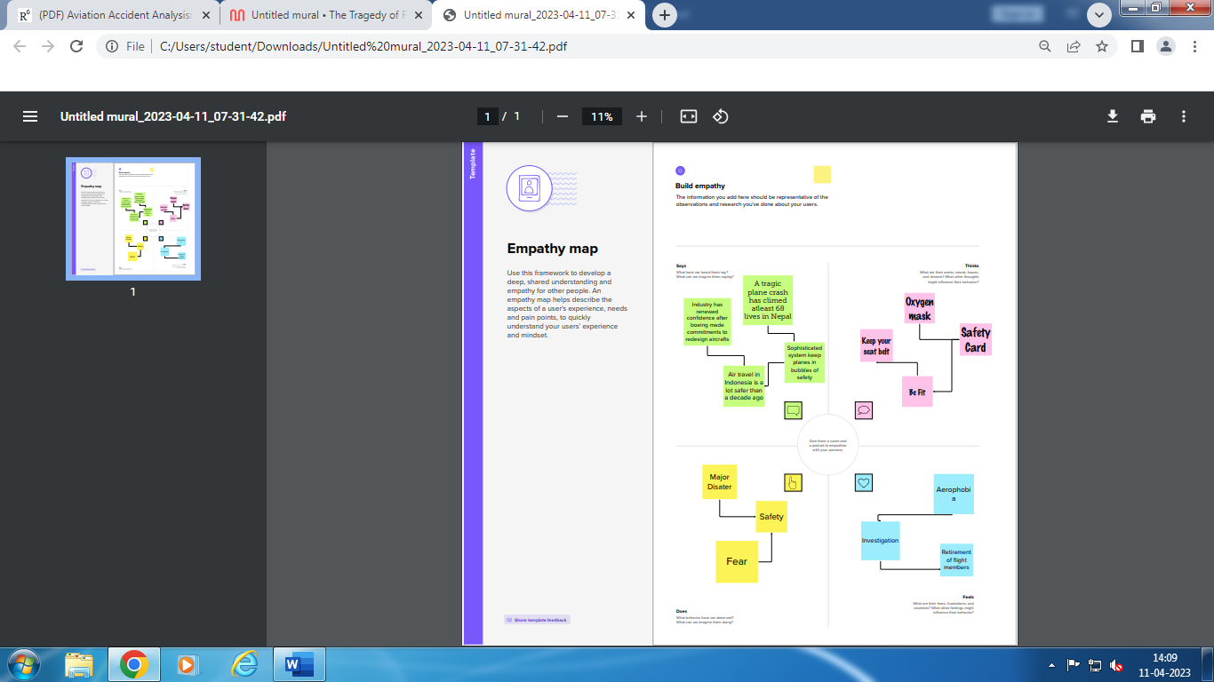

**2.2 Ideation & Brainstorming Map**

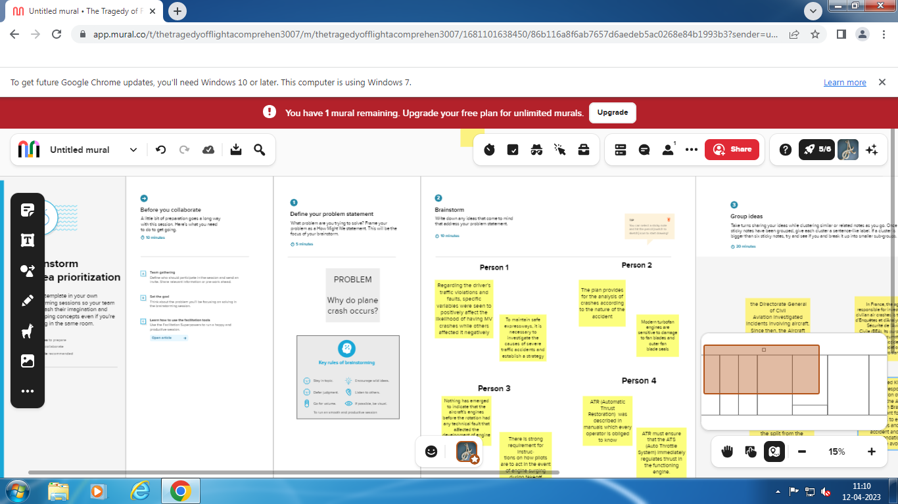 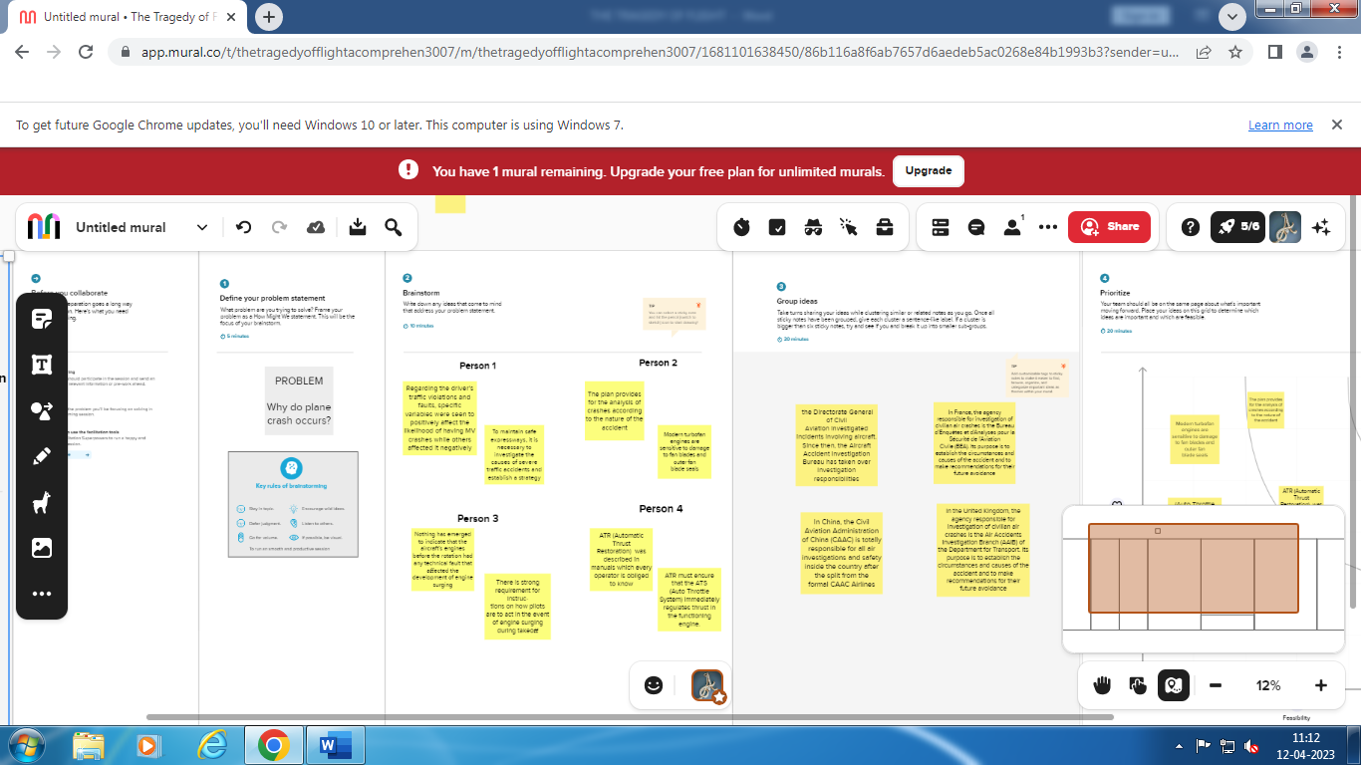

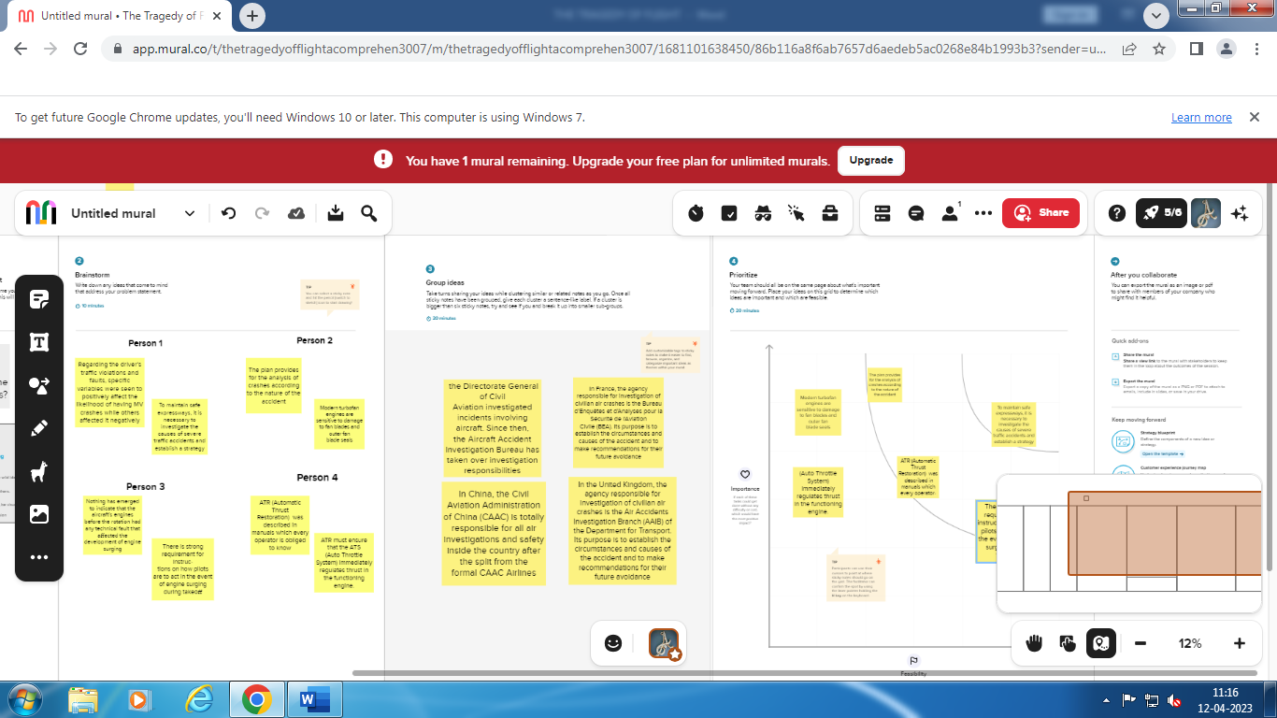 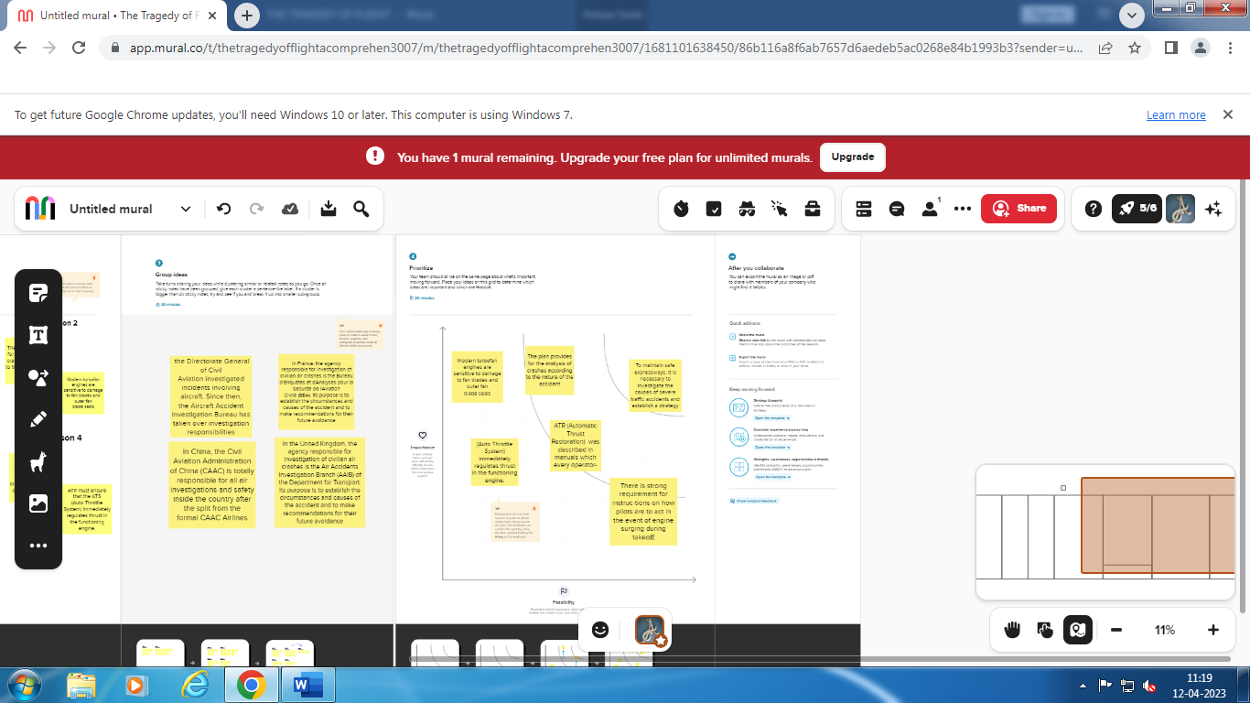

**3. Result**

Aviation accident analysis is performed to determine the cause of errors once an accident has happened. In the modern aviation industry, it is also used to analyze a database of past accidents in order to prevent an accident from happening. Many models have been used not only for the accident investigation but also for educational purpose.

**4. Advantages & Disadvantages**

**Advantages:**

Accident analysis is a major tool in obtaining an understanding of the existing situation and how it could be improved by ITS. It helps to provide an understanding of the most effective solutions and is essential for monitoring and evaluating the safety of the network.

The purpose of a crash analysis is to see how the plane will behave in a frontal or sideways collision. Crashworthiness simulation is one typical area of application of Finite-Element Analysis (FEA). This is an area in which non-linear Finite Element simulations are particularly effective.

The models used in accident investigation can typically be grouped into three types: sequential, epidemiological, and systemic models.

**Disadvantages:**

The odds of dying in a plane crash are about one in 11 million, but the chances of surviving depend on your seating choice. An aviation expert reveals a 44 percent fatality rate for travelers sitting in the aisle seats in the middle of the craft, compared with 28 percent for central rear seats.

Passengers at the front of the aircraft had a 65 percent chance of escape, while those at the rear had only a 53 percent chance.

Pilot error is the number one cause of aviation accidents. Piloting an aircraft requires lengthy training, a knowledge of the mechanical components of an aircraft, and hand-eye coordination skills to effectively and safely makeover an aircraft. Pilots also have to think ahead.

Any aircraft design has to solve three critical problems: lift - generating an upward force greater than the weight of the plane; thrust-propelling the plane forward; and control - stabilizing and directing the plane's flight.

**5. Application**

Crash Analysis can be used to analyze crash data and identify streets and intersections where concentrations of serious and fatal crashes occur. Safety is one of the most important factors to consider when evaluating a network.

Software lets engineers run crash tests inside computers rather than on roads. It also allows them to compare the performance of different designs early in the process while cars are still on the drawing board, saving money and injuries.

The purpose of a crash analysis is to see how the car will behave in a frontal or sideways collision. Crashworthiness simulation is one typical area of application of Finite-Element Analysis (FEA). This is an area in which non-linear Finite Element simulations are particularly effective.

The main goal of crashing a project activity is shortening a project while keeping costs at a minimum. It's about reducing the schedule as much as possible for the least amount of money.

**6. Conclusion**

The cause of this accident is the combination of several factors, ambiguously written procedures, inadequate training, unexpected operational situations or individual judg‐ments. Situational awareness, environmental and crew coordination factors, as well asshortcomings in pilot technical knowledge, skills and experience, also can cause acci‐dents. Other mistakes might be the result of improper airspace design or crew coordination. This analysisrevealed that among the pilotsthat caused the targeted accidents, 22 had flight experience for301 to 1000 hours and 20 had 1001 or more hours of experience. By age, those in their 50s and 60s combinedwere 34, accounting for nearly 60% of the total.Pilots with the total flight time of 301 to 1000 hours may have accumulated experience in familiarizationflights and recreational flights after obtaining a license and may have become confident in their skills.

**7. Future scope**

According to FMI, the Automotive Active Safety System market is estimated to be valued at US$ 12.78 Billion in 2022 and is projected to increase at a CAGR of 11.2% in the forecast period from 2022 to 2032. The global market for automotive active safety systems is expected to grow by an 11.2% CAGR in the next ten years**.**

The scope of occupational health and safety has evolved gradually and broadly encompasses: Promoting and maintaining overall wellbeing of workers in all occupations. Preventing occupational health hazards among the workers. Protecting workers from risks associated with their occupation.

The objective of a Safety Management System is to provide a structured management approach to control safety risks in operations. Effective safety management must take into account the organisation's specific structures and processes related to safety of operations.

**8. Appendix**